**Circuit Simulation Project**

[**https://esim.fossee.in/circuit-simulation-project**](https://esim.fossee.in)

**Name of the participant : S.PankajBharathi**

**Title of the circuit :clipping circuit**

**Theory/Description :** The Diode **Clipper**, also known as a Diode Limiter, is a wave shaping **circuit** that takes an input waveform and clips or cuts off its top half, bottom half or both halves together. This **clipping** of the input signal produces an output waveform that resembles a flattened version of the input.

**Circuit Diagram(s) :** **POSITIVE CLIPPER**

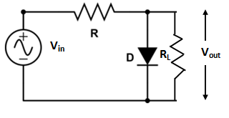

**NEGATIVE CLIPPER**

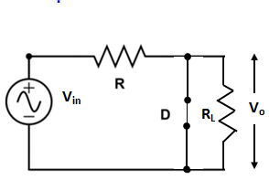

**Results (Input, Output waveforms and/or Multimeter readings) :**

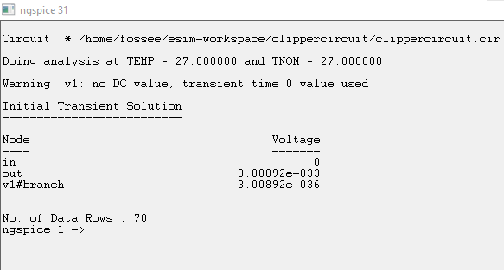

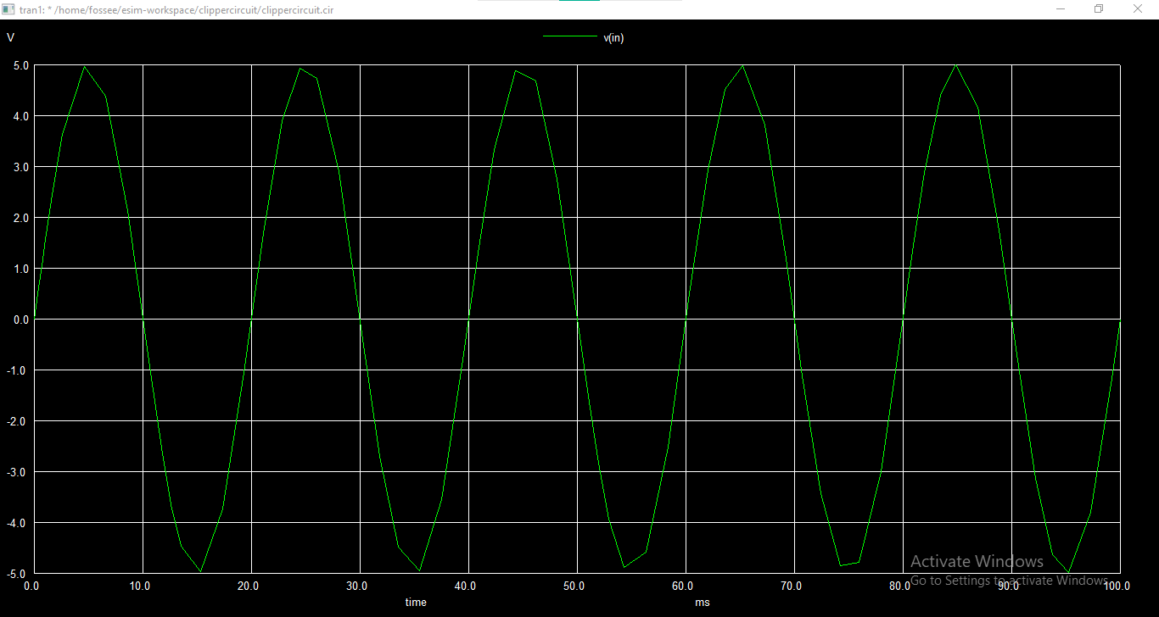

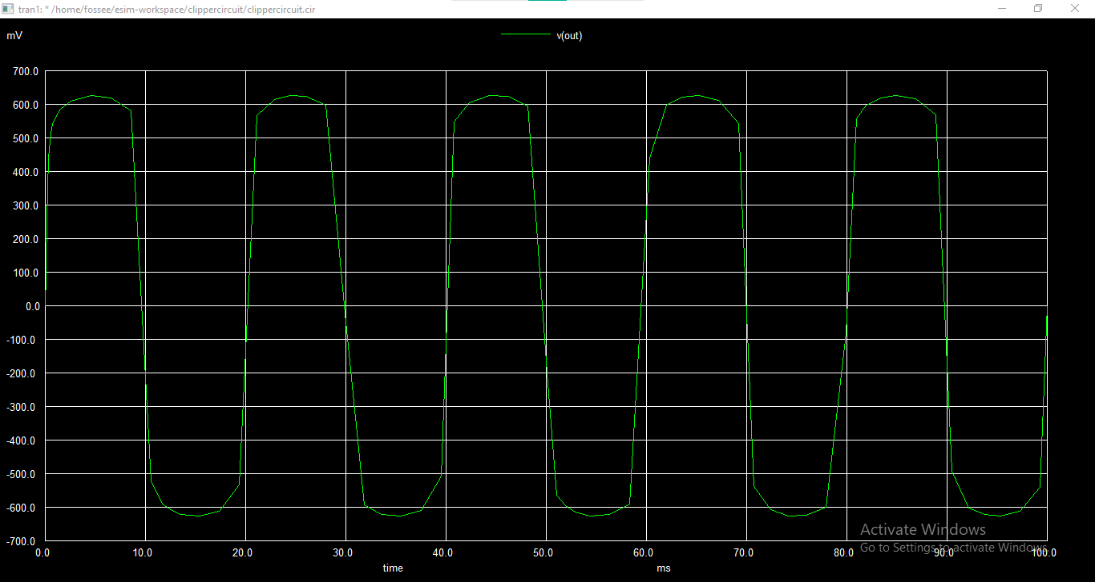

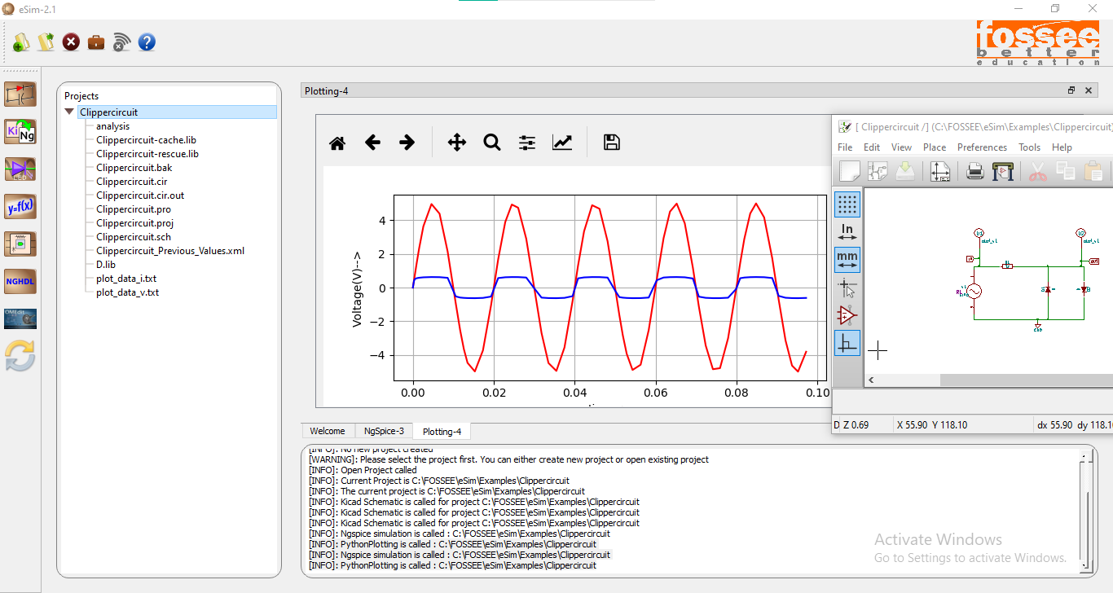

**Source/Reference(s) :**

GOOGLE, simulation handbook, esim emulation guide